
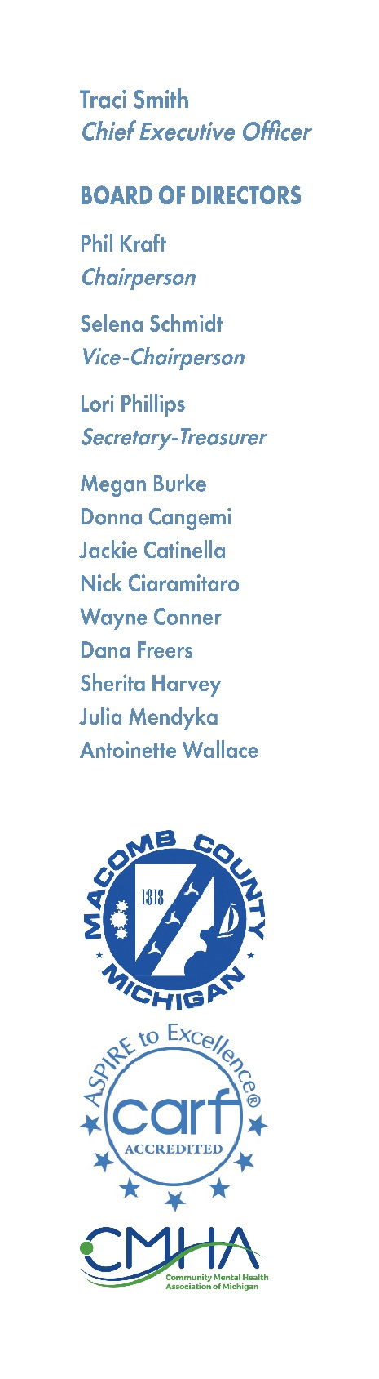

MCCMH BOARD RECIPIENT RIGHTS ADVISORY COMMITTEE
Thursday, April 16, 2026 – 8am
19800 Hall Road Clinton Township, MI 48038

A G E N D A
1. Call to Order
2. Reading of Mission Statement
3. Adoption of Agenda
4. Hearing of the Public
5. Policy Change (9-520)
6. RRAC Policy Training
- Appeal Policy (9-520)
- Authorizations and Functions (9-110)
- Rights Advocacy/Monitoring (9-135)
7. MDHHS RRAC Training
(Office of Recipient Rights Training Courses)
8. Other Agenda Items
9. Hearing of the Public
10.Adjournment

MCCMH Mission Statement
Macomb County Community Mental Health, guided by the values, strengths, and informed choices of the people we serve, provides quality services which promote recovery, community participation, self-sufficiency, and independence.

