
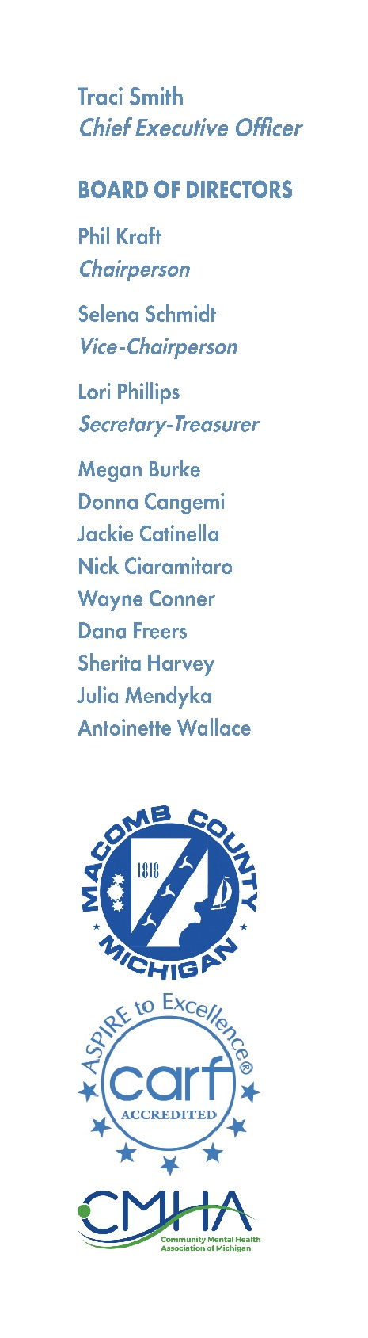

MCCMH BOARD RECIPIENT RIGHTS ADVISORY COMMITTEE
Thursday, December 18, 2025 – 8am
19800 Hall Road Clinton Township, MI 48038

A G E N D A

1. Call to Order
2. Reading of Mission Statement
3. Adoption of Agenda
4. Hearing of the Public
5. FY 2025 Annual Report
6. Tri-Annual Assessment
7. Hearing of the Public
8. Adjournment

MCCMH Mission Statement
Macomb County Community Mental Health, guided by the values, strengths, and informed choices of the people we serve, provides quality services which promote recovery, community participation, self-sufficiency, and independence.

