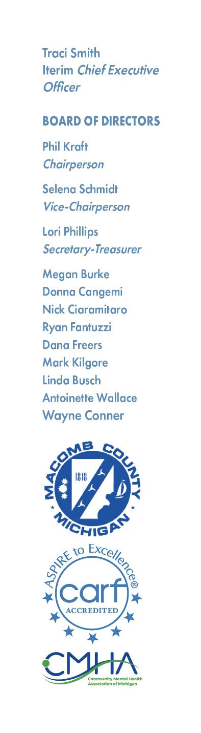

NOTICE OF MEETING

There will be a meeting of the PERSONNEL COMMITTEE of Macomb County Community Mental Health Services Board on Monday, May 20, 2024, at 12:00 PM, at MISD, 44001 Garfield Road, Clinton Township, MI 48038

**Megan Burke**

Megan Burke Chairperson

AGENDA

1. Call to Order
2. Adoption of Agenda
3. Hearing of the Public
4. Personnel Committee CEO Interviews (12pm-4pm)
5. Hearing of the Public
6. Adjournment