
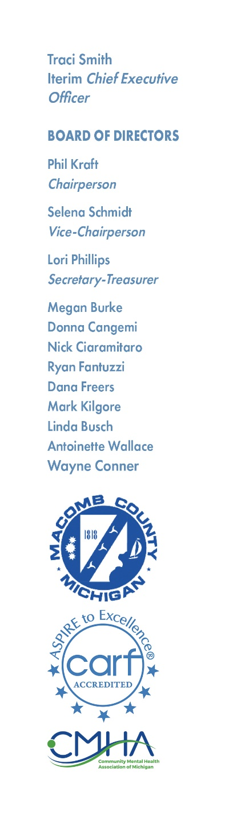

MACOMB COUNTY
COMMUNITY MENTAL HEALTH SERVICES BOARD
RECIPIENT RIGHTS ADVISORY COMMITTEE
Thursday, July 18, 2024 – 8am
19800 Hall Road
Clinton Township, MI 48038

A G E N D A

1. Call to Order

2. Adoption of Agenda

3. Hearing of the Public

4. Review Semi-Annual Report

5. Other Agenda Items

6. Hearing of the Public

7. Adjournment

THE MCCMH MISSION STATEMENT
Macomb County Community Mental Health, guided by the values, strengths, and informed choices of the PEOPLE WE SERVE, provides quality services which promote recovery, community participation, self-sufficiency, and independence.

