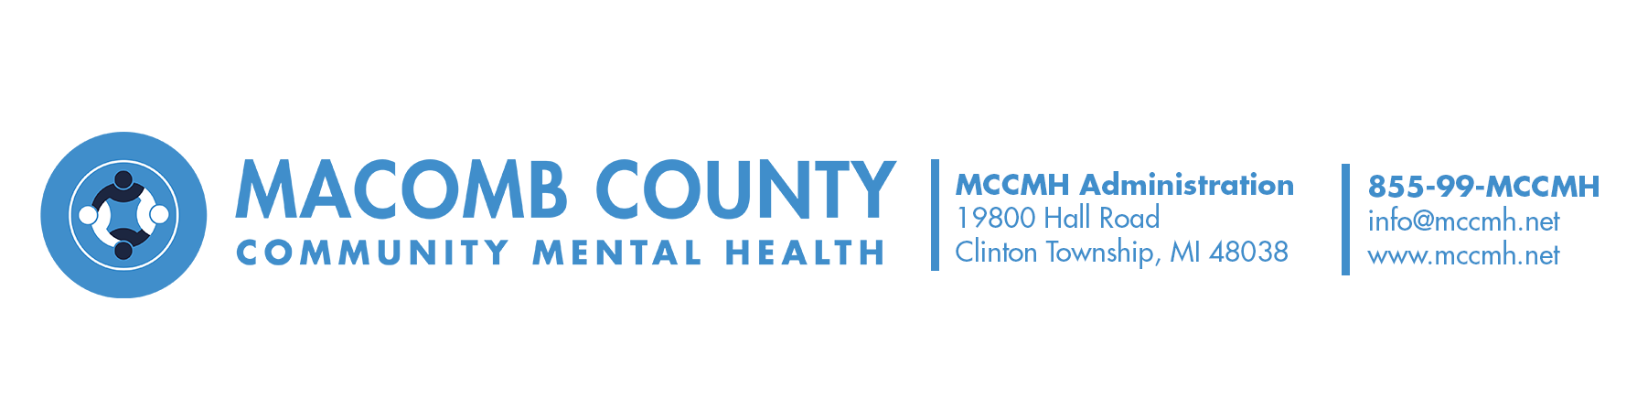

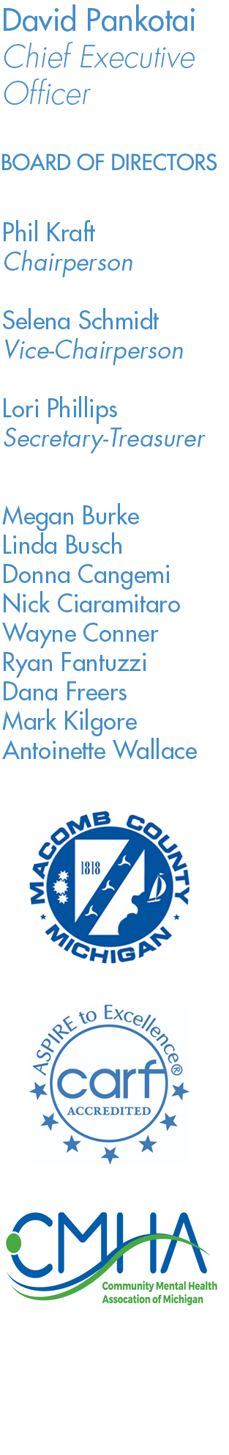

**MACOMB COUNTY**

**COMMUNITY MENTAL HEALTH SERVICES BOARD**

***EXECUTIVE COMMITTEE MEETING***

**Monday, November 27, 2023**

**10am**

**A G E N D A**

1. Call to Order

2. Adoption of Agenda

3. Hearing of the Public

4 Items for Discussion:

1. Interim CEO

5. Other Items for Discussion

6. Hearing of the Public

7. Adjournment