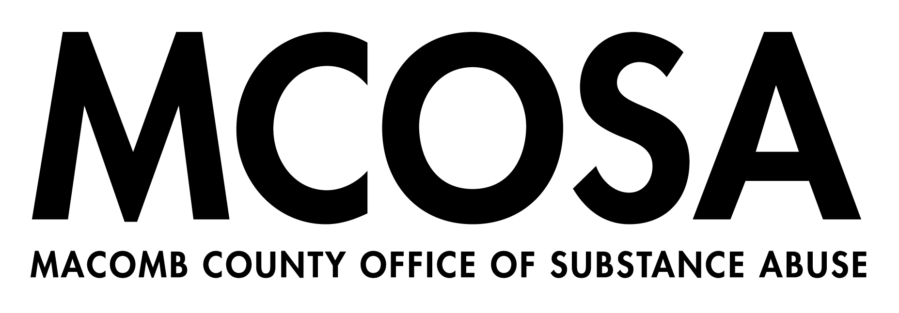

Community Coalitions and Organizations

Chippewa Valley Coalition for Youth and Families
Meeting: Virtually 2nd Tuesday of month, 3:30 PM
Location: CVS Admin Bldg,
19120 Cass Ave., Clinton Twp, 48038
Chair: Charlene McGunn Ph.D., Executive Director
(586) 723-2360
cmcgunn@cvs.k12.mi.us
Website: www.cvcoalition.org

Clintondale Coalition
Next Meeting September 21, 2022
Meeting: Virtually- 3rd Weds of every month, 2:00 PM
Co-Chair: Lisa Rector, Macomb Suicide Prev. Coalition/Sanford House
Contact: Adrienne Gasperoni, Community Organizer at CARE of SEM
(586) 218-5271 or AGasperoni@careofsem.com
Clintondalecoalition@gmail.com
Website: www.facebook.com/clintondalecoalition

Eastpointe Community Action Coalition
Meeting: Virtually 1st Thurs of month, 10:00 AM
Chair: Robert Baker
Contact: Monica Eaton, Community Organizer at CARE of SEM (586) 218-5279 or Meaton@careofsem.com
Website:
www.facebook.com/EastpointeCommunityActionCoalition

Fraser Community Action Team
Meeting: Contact for upcoming dates and times
Chair: Margaret Rose Ferianc
34270 Garfield, Fraser, MI 48026
(586) 439-7200 mrosef@me.com
Contact: Steve Norgrove Steven.Norgrove@fraserk12.org or Monica Eaton, Community Organizer at CARE of SEM (586) 218-5279 or Meaton@careofsem.com
Website: www.facebook.com/FraserCommunityActionTeam

Mt. Clemens Community Coalition for Youth and Families
Meeting: Contact for upcoming dates and times
Chair: Roger Burton
Contact: Roger Burton rhberb_rhb@msn.com
Website: www.facebook.com/MCCoalition

Northern Macomb Prevention Coalition
Meeting: 3rd Thursday of month, 9:00 a.m.
Location: Macomb Family Services
124 West Gates, Romeo, 48065
Contact: Joe Thayer
(586) 752-9696 x211
jthayer@macombfamily.org
Website: www.northernmacombpreventioncoalition.org
Roseville Community Coalition
Meeting: Contact for upcoming dates and times
Contact: Monica Eaton, Community Organizer at CARE of SEM (586) 218-5279 or Meaton@careofsem.com
Website: www.facebook.com/RosevilleCommunityCoalition

Shores Network for Action and Prevention
Meeting: Virtually – 1ST Thurs of month, 4:00 PM
Contact: Adrienne Gasperoni, Community Organizer at CARE of SEM
(586) 218-5271 or AGasperoni@careofsem.com
Website: www.s.n.a.p.coalitionscs@gmail.com
www.facebook.com/SNAPcoalition

Sterling Heights Drug Free Coalition
Meeting: 2nd Thurs of month, 5:30 PM
Chair: Sgt. Aaron Susalla asusalla@sterling-heights.net
Contact: sterlingheightsdfc@gmail.com and Erika Bradbury, Prevention Program Manager at CARE of SEM
(586) 541-2273 ext. 228 or Ebradbury@careofsem.com
Website: www.shdfc.org
Warren-Center Line Prevention Coalition
Meeting: Virtually- 4th Monday of month, 1:00 PM
Chair: Irene Salem, Judson Center
Contact: wcpc4change@gmail.com or Contact: Adrienne Gasperoni, Community Organizer at CARE of SEM
(586) 218-5271 or AGasperoni@careofsem.com

Teens Talking Truth –
Macomb Youth Prevention Coalition
Meeting: Contact for upcoming dates and times
Contact: Erika Bradbury, Prevention Program Manager at CARE of SEM
(586) 541-2273 ext. 228 or Ebradbury@careofsem.com
Website: www.careofsem.com

